**MENTOR AND STUDENT DATABASE**

**Front end URL:** <https://leafy-monstera-91ab34.netlify.app/>

**Front end Data:**

Mentor Data:

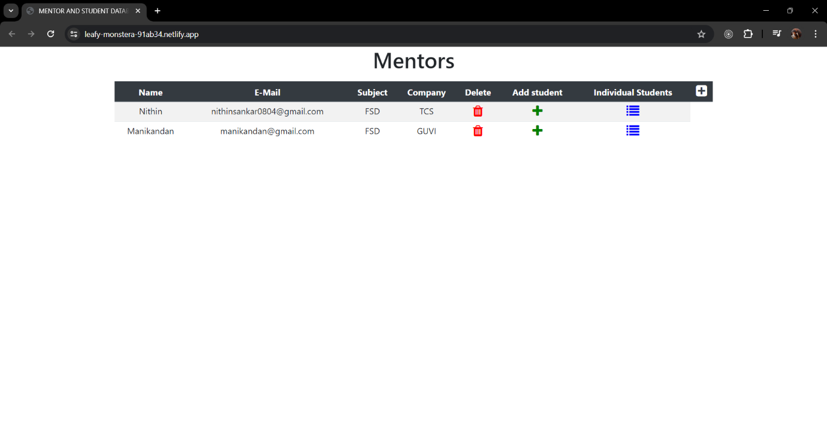

Add Mentor Data:

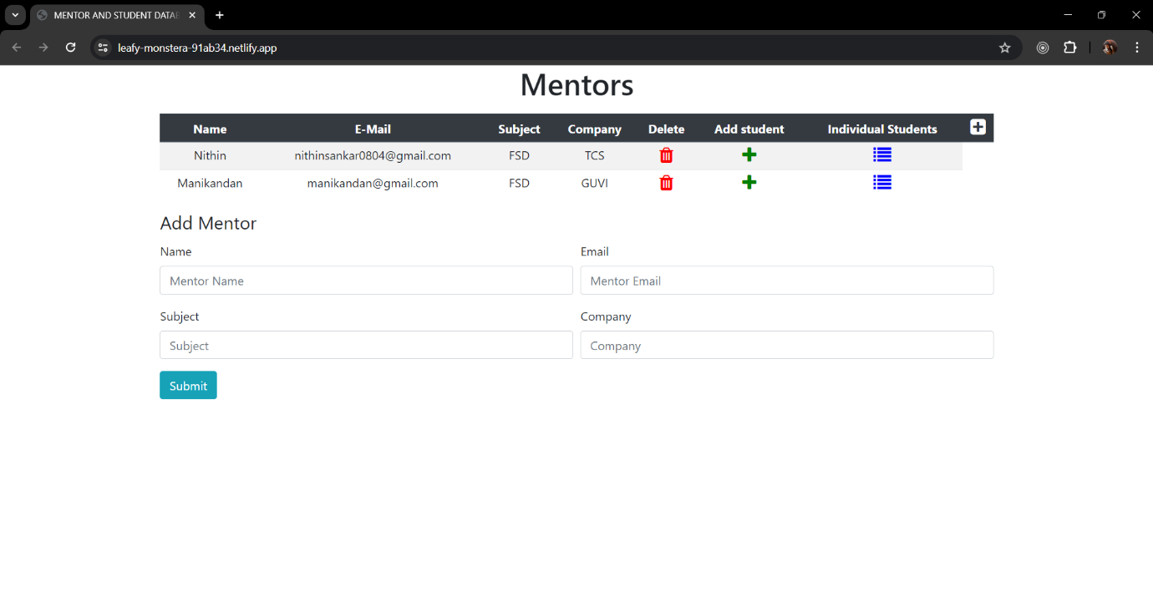

Student 1 Data:

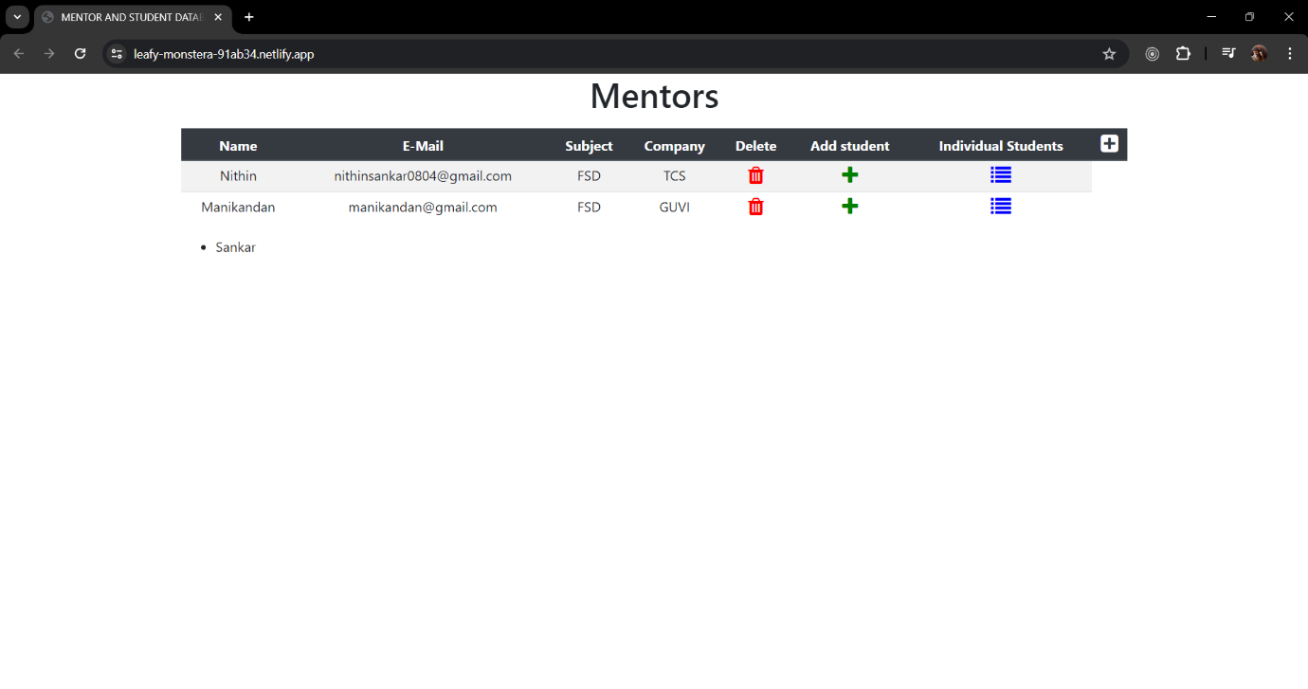

Student 1 Data:

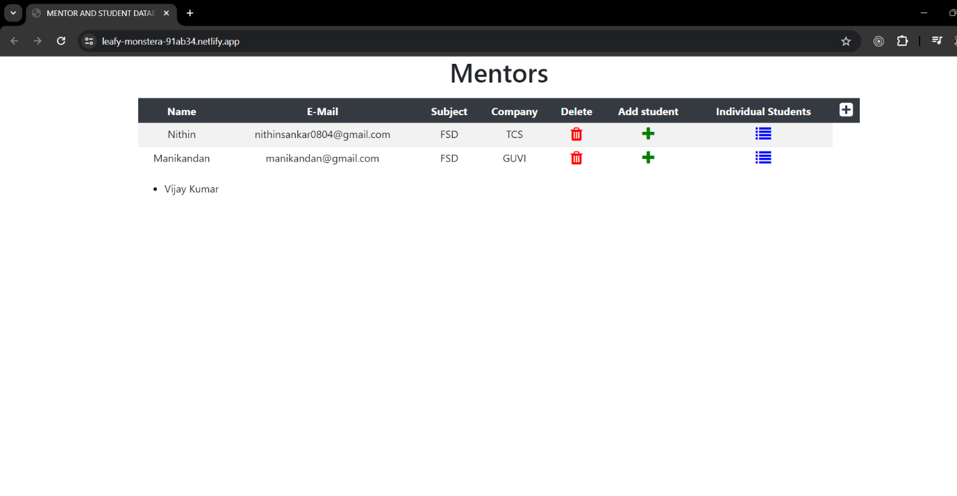

Add Student Data:

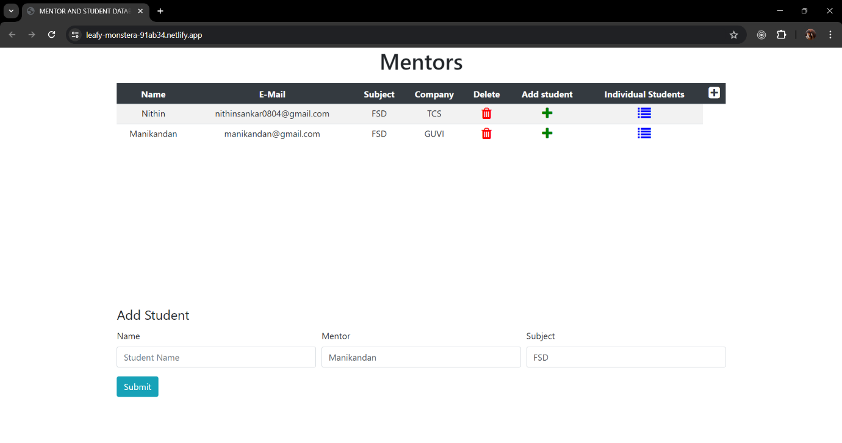

**Postman URL:**

Get Mentor Data: http://localhost:8000/api/mentor

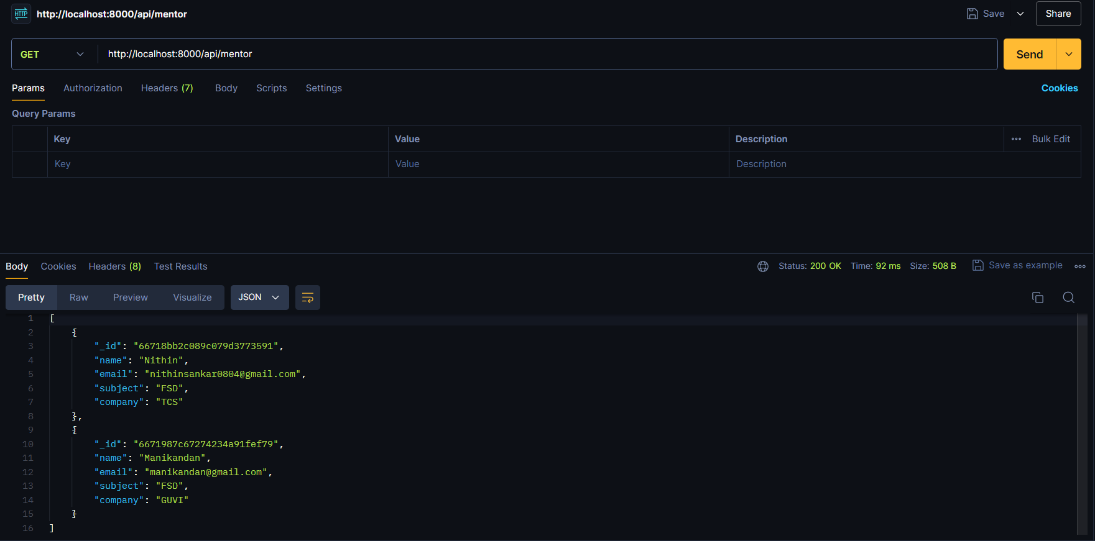

Get Student Data: [http://localhost:8000/api/student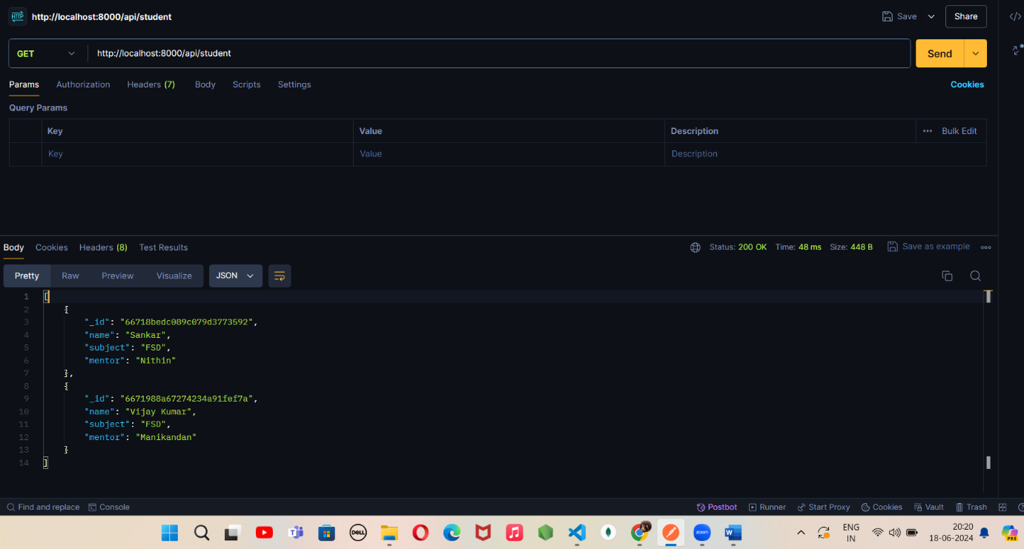](http://localhost:8000/api/student)

Get separate Student and Mentor Data: <http://localhost:8000/api/student/:mentor>name

